Maths – 17.6.20
LI: To tell the time using ‘quarter to’
There are 4 questions and challenges to complete today.
You do not need to print, please just write your answers numbering 1, 2, 3, 4. You can also draw the clocks for question 4.
Show the same time on your clocks as you answer each question.
1.
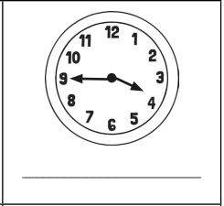

2.
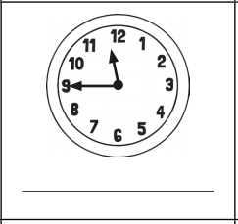

3.
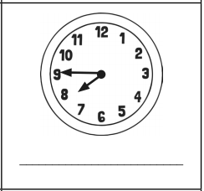

4.
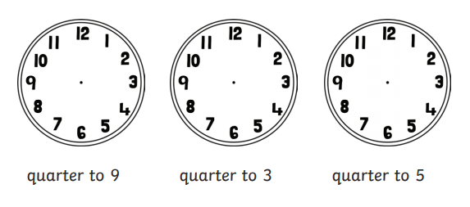
Challenges
Please answer at least one of the challenge questions –1 star, 2 stars or 3 stars (mild, spicy, hot)

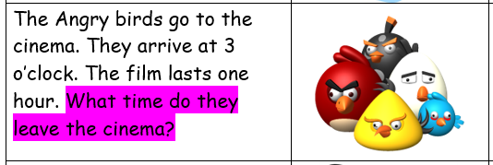

2.
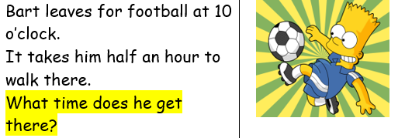

3.
