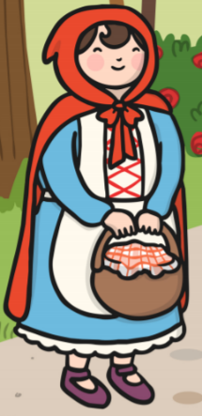

Grandma

big

eyes

you

what

have

ears

teeth