Tuesday April 28th Literacy
Download the learning input- ‘Little Cloud’ by Eric Carle
Look at the front cover- Did you know that this story was written by the same author as ‘The very Hungry Caterpillar’?

Read the story together.

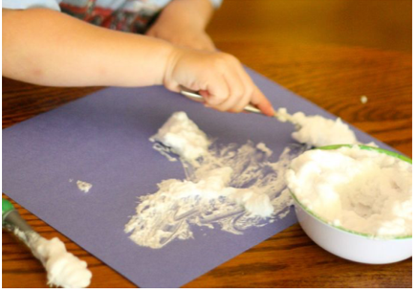
Use paint or shaving foam mixed with PVA glue, to make a cloud. Work on coloured paper for the best effect. Try to make your cloud look like an animal or object.

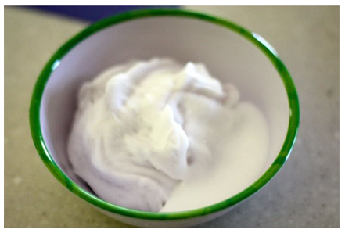
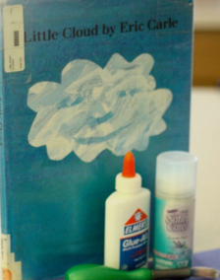

Print off, or copy, the sentence starter. ‘My little Cloud changed into a …’
Use descriptive words to finish the sentence ‘It was…
Cut out your writing and paste under your picture.

