Tuesday 31st March 2020
Here is your second clue to solve the Easter mystery!
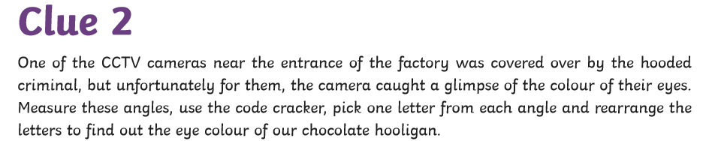

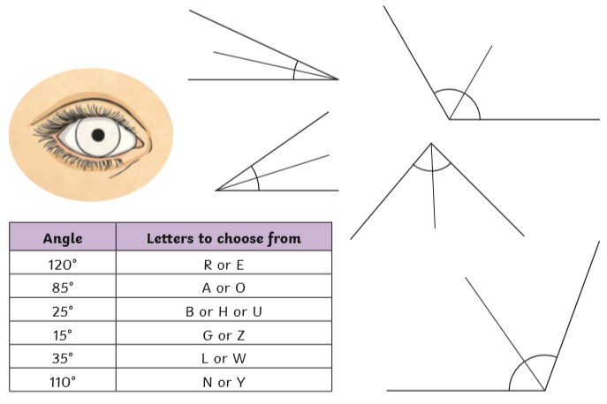

Please note: These angles are not drawn to scale. Use logic to solve this! i.e. there are clearly two angles over 90 degrees, there is one angle that is almost exactly 90 degrees…What could the other angles be? Remember, each angle you choose must give you one letter…these letters when put together can be rearrange to spell a colour.

