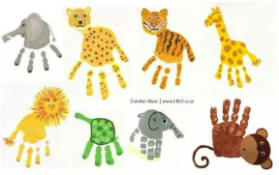
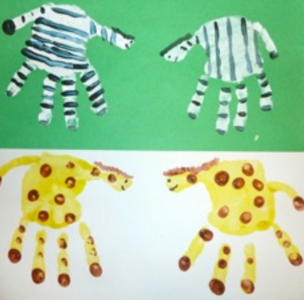
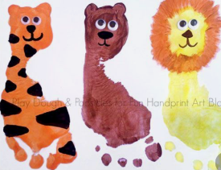
Tuesday 2nd June
Art lesson instructions

Have a go at making one or more of these crazy zoo animals using hand and foot prints.
Decide on an animal of your choice. Use a paintbrush to paint a layer of base paint onto your hand or foot and quickly print onto a piece of paper. Allow to dry before adding details such as tails. spots or stripes, ears and eyes.

