Greenfield Primary School
York
Y01 6FA

18th June 2019
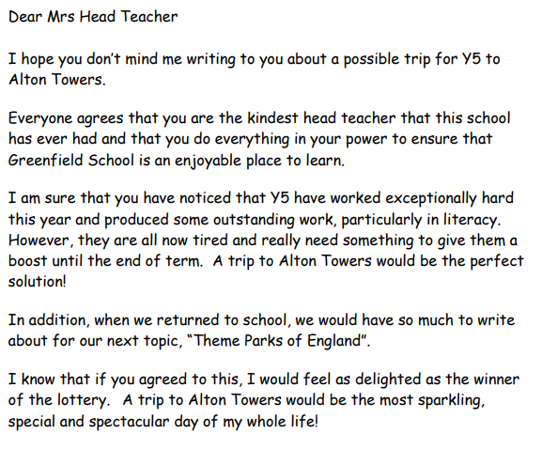
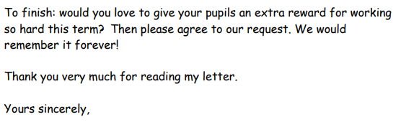
Tom Green

Caxton Primary School
Tin Hall Road,
London,
E31 5TM.

7th January 2020
Dear Mr Cooke,
You are a truly kind and reasonable headteacher who always has time to listen to the pupils and having been a pupil at Caxton Primary for the last few weeks, I feel I should share my feelings about the food served in the lunch hall. Serving chips every day is unacceptable and I hope, by writing this letter, to convince you that this must change.
To begin with, everyone knows that chips are unhealthy. They are deep fried in oil or fat which the children will eat which is not good for children to eat every day. Chips are also very high in starch. Too much starch in our bodies will upset these poor children's stomachs. I know that you care deeply about the pupils at your school and you would not want us to be in such an unhealthy environment.
If we had the option of more healthy food, such as rice, pasta and potatoes we would feel better and would learn more. I am sure you would feel very happy to know you have helped us.
Please consider the points I have raised in this letter carefully. My fellow pupils and I look forward to hearing your response
Yours sincerely
Mustafa Berger 5XJ

101 Smith Street
Sutton
CR4 5DR

27th April 2009

Dear Miss Green

I am writing you about the plan to close my local swimming pool. I am extremely concerned about this as I use it every day to keep fit. My neighbour, Mrs Hunter told me to write to you as she said you are exceedingly kind and understanding.

Swimming is the best form of exercise for many people with disabilities. It is the only time that people with physical disabilities are able to move freely without the restriction of their wheelchairs. A true relief, wouldn’t you agree?

If you continue with your plan to close our swimming pool then the nearest pool with disabled access is over 50 miles away, I worry about how they are going to travel this distance. I know that you will share my worry as you are caring and kindhearted.

Please give my letter your full attention as I feel deeply passionate about keeping our swimming pool open.

Yours sincerely

Mr T Harvey

The Cottage
Newbury
Berkshire
RG17 2QT

10th December 2017

Dear Mr Cannings

I am writing to you about our recent conversation about getting a dog. You are so kind and caring that I know you will make a fantastic owner.

If we got a dog, we would all became fitter and healthier as we would have to walk the dog twice a day. Also, our children have wanted a dog for so long, they would be extremely happy. It would also give them responsibility as they would have to help walk, play and feed the dog. Our family dog would be so lucky to have such a loving family, surely that makes you feel incredibly happy.

I worry about our family fitness if we did not get a dog as we would not have a reason to go out for regular exercise. As I have already said, you would make such a wonderful, caring owner, think about how the dog would feel missing out on having a loving home. How would we know if the dog went to a loving home?

Please think very carefully about this as I feel having a family dog would be beneficial to us all.

Yours sincerely

Mrs Cannings

