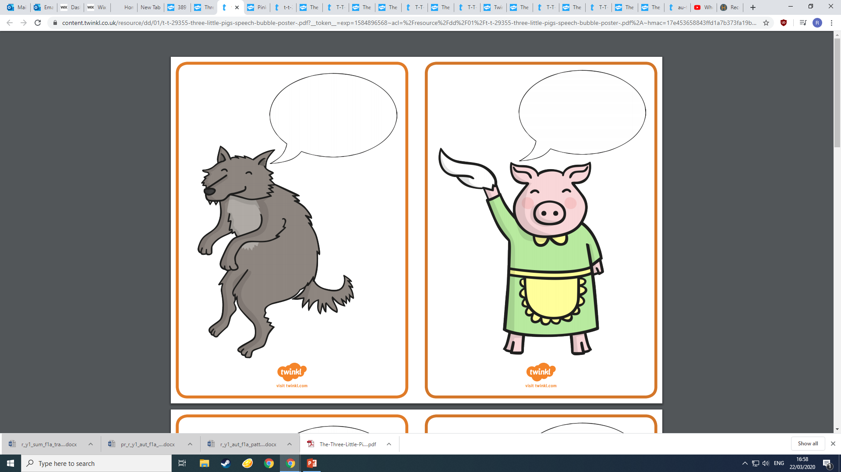

All

to

better

hear

with

eat

see

you

the