Hello Years 5&6, I hope you are excited to see your maths learning this week. This is a great opportunity for you to work at your own pace and develop some fantastic maths skills. As ever, do your best, present your work carefully and remember to email me your work each day. I’m looking forward to seeing how you get on.
To help you with your maths this week, you should use the maths knowledge organiser ‘properties of shape’ that you have in your resources pack. One side of this knowledge organiser gives you all of the information that you will need about angles to help you this week. Of course, you can email me if you get into any difficulties. You will also need the protractor from your resource pack and a ruler.

Monday 23rd March
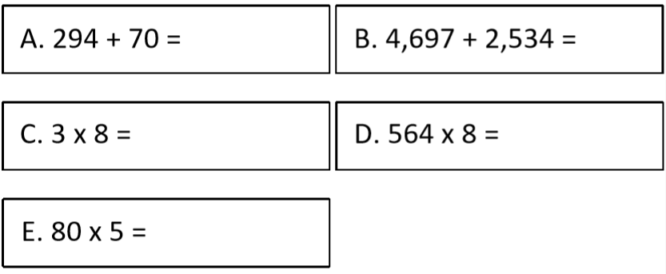
- Begin your maths lesson today by trying to complete these 5 questions in 5 minutes in your maths book. Good luck!

- Go through the presentation ‘Angles 1.
- Practise drawing lines and angles in your maths book similar to those in the pictures below. Measure the lines and then the angles accurately. If you get stuck using the protractor, then you can use this YouTube video to remind you how to use it.
https://www.youtube.com/watch?v=ALcBC-p82Q0

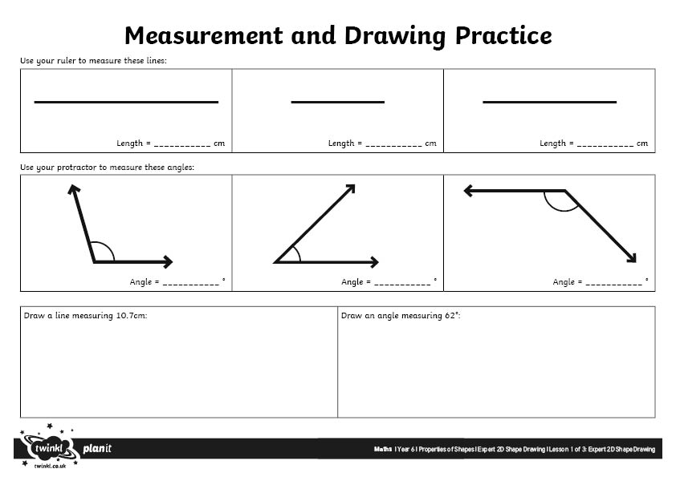

1

Tuesday 24th March
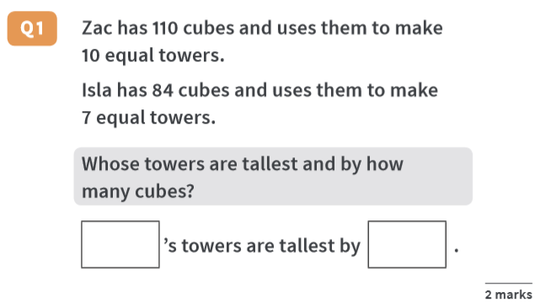
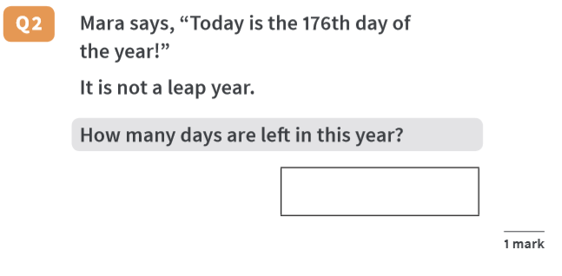
Begin today’s lesson by completing these quick reasoning questions.
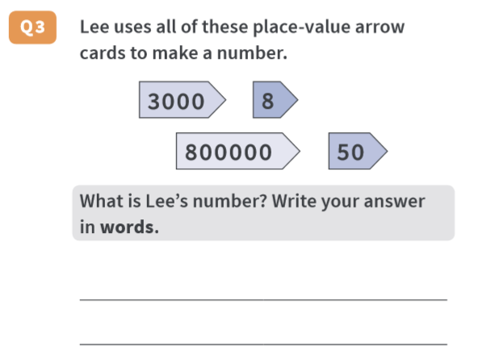

Using your log on details for MyMaths, which you will find in your resources pack, complete the angles task that you have been set on measuring angles. Remember, you can always go back to the PowerPoint on Measuring angles or the YouTube video above if you need help. In your resources pack you also have a maths knowledge sheet on angles. Use it for reference if you get stuck or email me if you need more help.

Wednesday 25th March 2020
- Begin your maths lesson today by trying to complete these 5 questions in 5 minutes in your maths book.
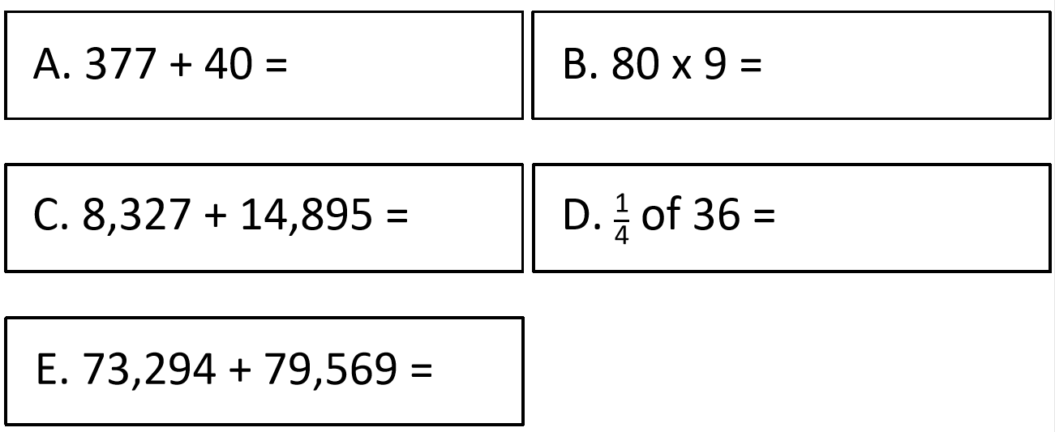

- Go through the PowerPoint presentation ‘Angles on a straight line’, then choose your level of challenge on the below tasks and find the missing angles.

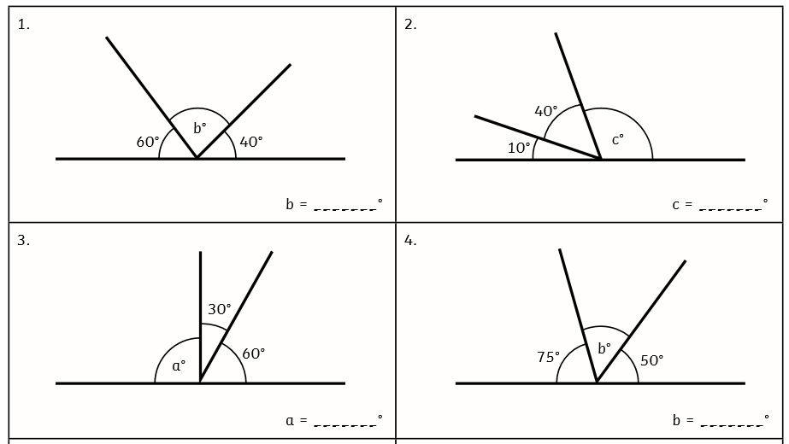
Mild
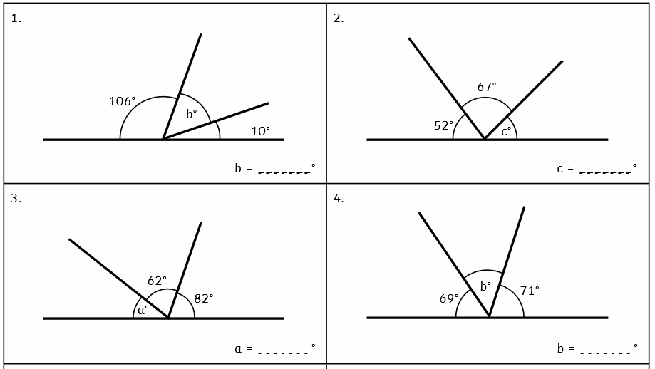
Spicy

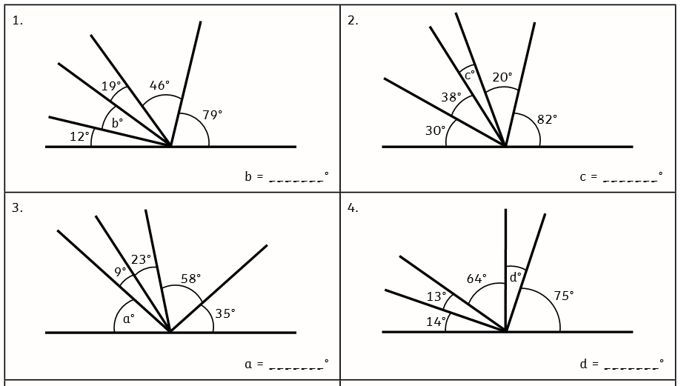
Extra Spicy

Thursday 26th March
Begin today’s lesson by completing these reasoning tasks. I wonder if you can time yourself to see how long it takes to complete them.
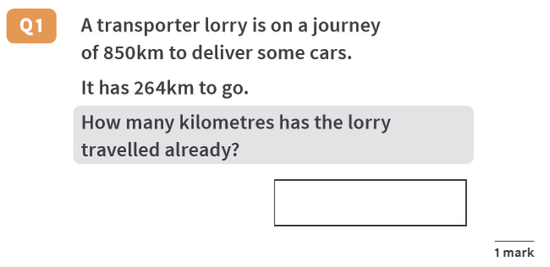

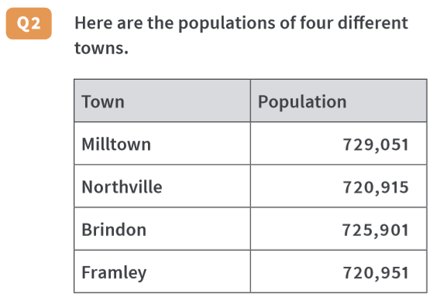

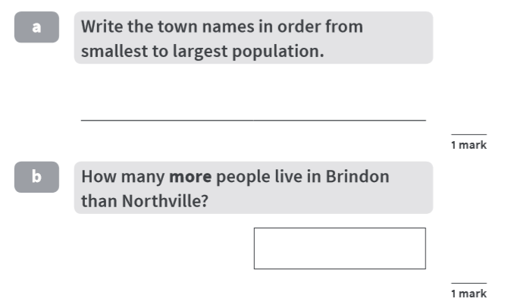

Today’s task is to consolidate your learning on angles on a straight line. Begin this task at group 1 questions. Can you complete them all and move on to group 2? I wonder if you can get to the end in less than 40 minutes. Time yourself.

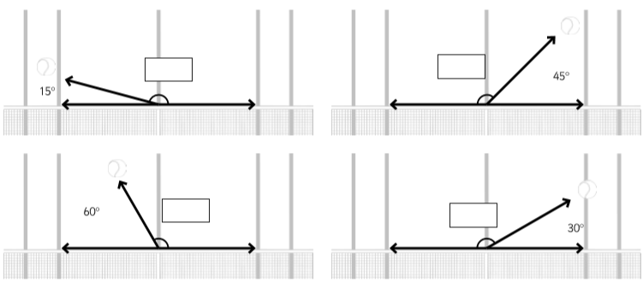
Group 1

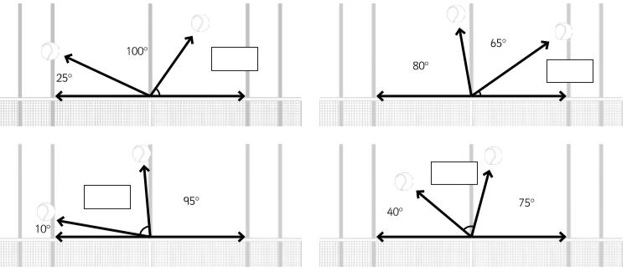
Group 2

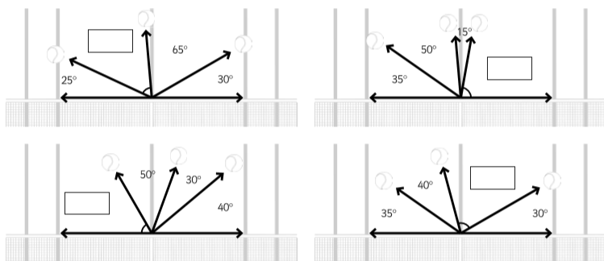
Group 3

Friday 27th March

Good morning! You’ve almost made it to the weekend. Well done for keeping on top of your maths learning all week. Today’s maths lesson begins with some arithmetic practice. Can you complete today’s questions in 5 minutes or less?
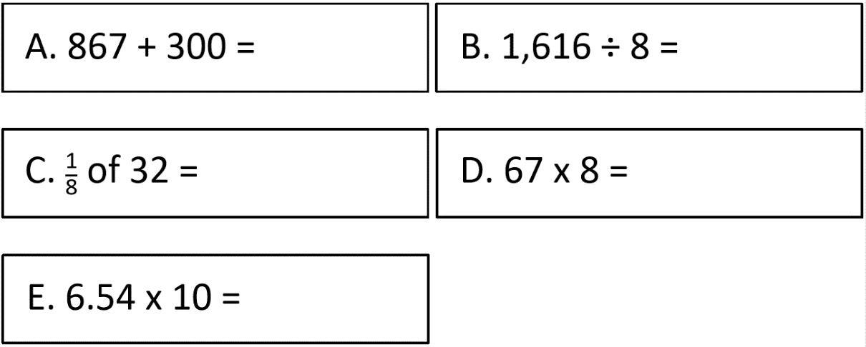

When you have completed these, go through the PowerPoint ‘Angles in a Turn’. Once you feel ready, you may choose your level of challenge to find the missing angles in a turn. If you need any additional help, you could use this YouTube video to help you: https://www.youtube.com/watch?v=Yt2yvO-xkhY

Mild
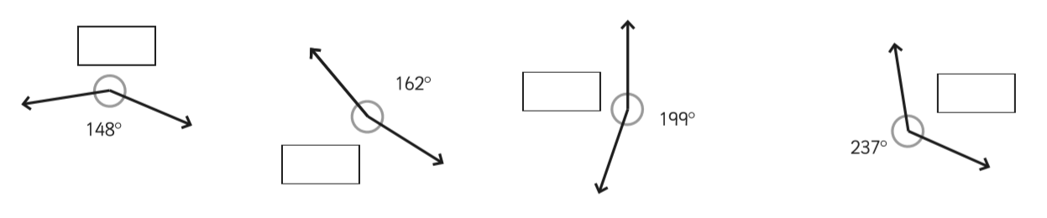

Spicy
HINT – The angle represented by the small square = 90º

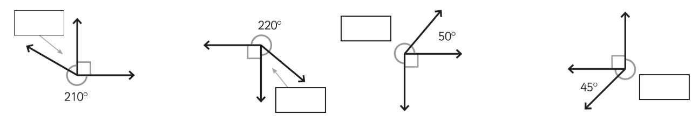

Extra Spicy

