
Beenham Primary School Newsletter

___________________________________________
VALUES www.beenhamschool.co.uk
EDUCATION

 Dolphin Award  | 31st January 2020  Our VALUE this month is  Hope
Luke Rossiter  It gives me such joy to present this month’s Dolphin Award for the value of HOPE to Luke Rossiter. When the teachers were discussing the characteristics of HOPE, it immediately became apparent who had shown these qualities and we all agreed that Luke was a deserving recipient.  HOPE is a value that allows us to persevere and build resilience. Martin Luther King Junior once said that ‘Everything that is done in the world is done by HOPE’ and when we have HOPE, we have the courage and determination to achieve amazing things!  Luke has achieved so much already this year as a result of his HOPES and dreams. He has shown real courage when asking teachers and peers for help when he needs it and has worked so incredibly hard to achieve his goals through practice and perseverance. All these qualities and values gave Luke the self-belief to perform in the Christmas play. cont | What’s happening in school over the next couple of weeks?  - Wednesday 5th February – Mai Class Forest School 9.30am – 11.45am  - Friday 7th February – Mosi Class Assembly (parents welcome)  - Friday 7th February – Y5 Maths Challenge, St Gabriels  - Monday 10th February – last Cooking Club  - Wednesday 12th February – Mai Class Forest School 9.30am – 11.45am  - Wednesday 12th February – Mosi Class at Theale Green to watch Sister Act  - Friday 14th February – Singalong Assembly (parents welcome)  - Friday 14th February – Valentines Disco 3.15pm-4.30pm
. His performance was astounding due to his dedication, patience and positivity. Luke has shown that having HOPE allows us to achieve our dreams and the feeling at the end when you succeed is wonderful!
Congratulations Luke, it makes me feel so proud and lucky that you are a part of our school.





Mai Class – Felix Roe and Orianna Stretton

Torak Class – Ben Hewitt and Jessica Reeve

Mosi Class – Noah Errington and Ashton Breakspear

Red Team – 579

Blue Team – 638

Green Team – 665

Yellow Team – 682

Y5 SCIENCE OUTREACH DAY
Pangbourne College

When we got there the six schools were split up into groups. We started off with physics, the Head of Science taught physics then we went off into our groups and made a circuit.

Then somehow he produced lighting or more known as electricity. After Physics, we had a really early lunch at 11am. After lunch, we did biology. We all learnt about polyps. We even made edible polyps to eat which were made of banana, biscuit, jam, strawberry laces and sprinkles.

After biology, we had cookies while the helpers were eating their lunch.

We soon went on to our last subject, chemistry. In chemistry we did fingerprints to find out who stole the goldfish call Flippy. We all agreed that we like chemistry the most. We are lucky to go there and we enjoyed it very much.

By Tilly New, Lottie Haines, Lexie Whitter, Ashton Breakspear

Y4 MATH’S CHALLENGE
St Gabriels

On Monday, four Y4s were invited to St Gabriels School for a maths challenge. There were about 20 other schools there also taking part.

We were put into twos by our teachers. The teams in our group were Warwick and I as one team and Harry and Maddie as the other. We were all competing against each other.

We were given a booklet and told the rules by Douglas (who I think was a maths teacher at the school). The challenge involved difficult multiplications and divisions and problems to solve (such as pictures of triangles that we had to fit perfectly into bigger triangles).

Other things in the challenge were: Pairing cards up that added up to a given number, Make 24 – where you have to work hard with your partner to solve as many ways to make twenty-four. There was also a game where you had to know what comes next in the times tables and one challenge where you had to find the pattern in the letters, a bit like code!

The scores were added up and Warwick and I came 7th overall.

It was really good!

By Thomas Grace

Y4 MORE ABLE WRITERS
Theale Green

Every other Tuesday, Charlie, Thomas, Tia, Harry and Warwick go to Theale Green to work with Y8’s on a book call Kensuke’s Kingdom. We went with Englefield Y4’s.

We had a booklet that had activities in and we completed them every week. We had lots of fun and we enjoyed the book.

By Tia, Warwick, Harry, Charlie and Thomas

Mai Class information

The children have really enjoyed learning about the Lunar New Year and we have had fun making money envelopes, lanterns and dragons as well as cooking rice and learning the story of Chinese New Year.
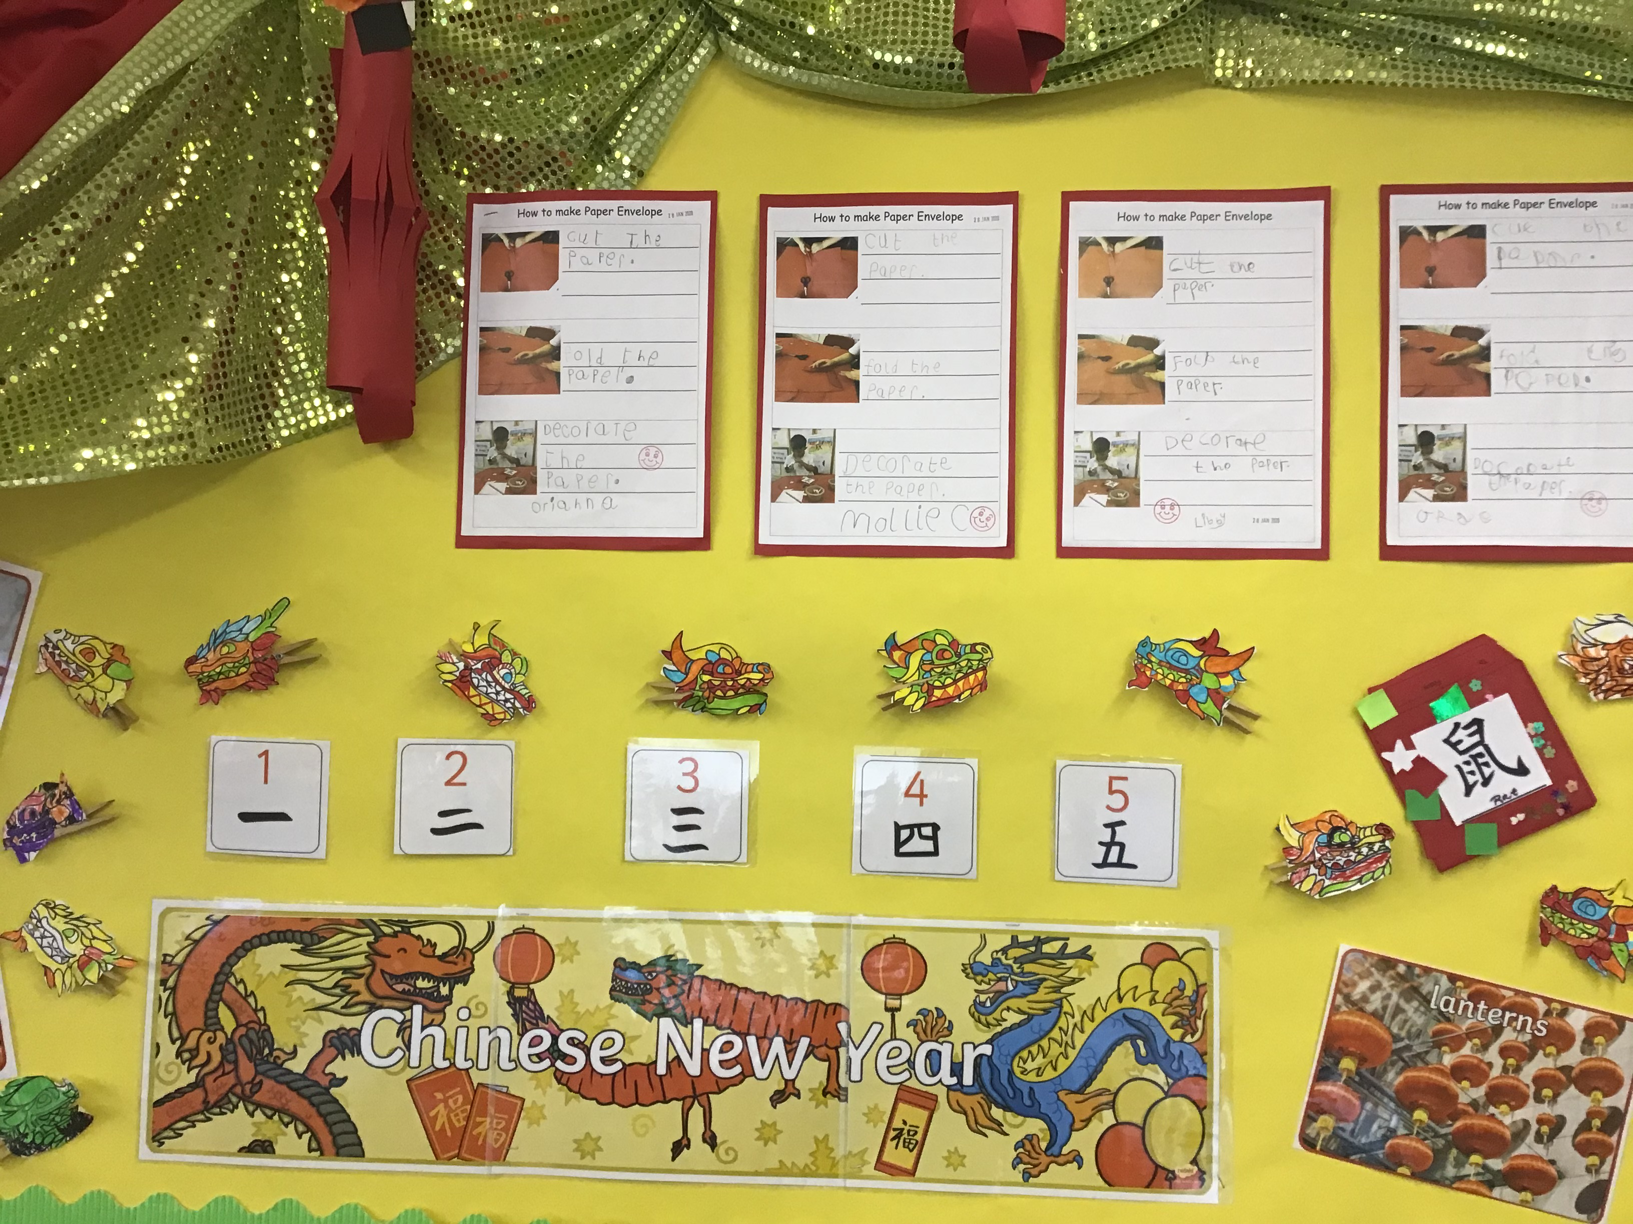

We have been learning how to read, write and follow instructional texts over the past few weeks and this week the children wrote instructions to make a Chinese paper envelope. We had some wonderful writing. I am so proud of the work that the children are producing.

Well done Mai Class!

Torak Class information

This week in literacy, Torak class have been looking at a range of poetry from around the world. In line with our topic ‘celebrating culture and diversity’, the poems were all about traditions. The children shared their own family traditions, such as ‘family roast dinners’, ‘family holidays’ and ‘Christmas’ and wrote their own ‘traditional poems’. I was so impressed with their wonderful poems which included rhyme and repetition to emphasise feelings and ideas. ‘I love Christmas, it makes me feel nicer and brighter’, ‘I love a Sunday roast, I am thankful, thankful.’

Continuing our learning on rivers, the children looked at the features of The River Thames and The River Yangtze in China. In groups, they discussed and compared similarities and differences in the size, surroundings and cleanliness of water. ‘The river dolphin is extinct because of too much pollution in the River Yangtze’, ‘The River Thames is the cleanest river in the world!’.

Have a lovely weekend

Mrs Cannings

Mosi Class information

This week we have enjoyed delving a little more into our topic. The children have learnt the basics of Chinese brush strokes to recreate the traditional 'Four Gentlemen' of Chinese art. There are some wonderful pieces of art which will be going on display shortly.

In our English lessons this week we have enjoyed reading the book True of False? together to discover some amazing facts and pieces of information. The children have learnt to use adverbs of possibility to express thoughts and ideas which they are not sure about. We have moved onto modal verbs of certainty recently and the children have enjoyed creating their own sentences to express possibility and certainty.

In maths we have begun a new unit of work on fractions and I've been impressed with how the children have very quickly grasped equivalency in fractions (and decimals and percentages for Year 6). They have worked brilliantly to apply their new learning to problem solving and reasoning and are becoming confident in their use of mathematical language such as improper fractions, mixed number fractions, equivalency and percentages. Well done everyone, you have had a great week and deserve a good rest this weekend!



Children under 5 get free milk in school. Children 5 and above can still have milk but you need to pay. If youd would like milk then please visit the Cool Milk website and register your child or see Mrs Appleby in the office who can give you a registration form.


Eco Brick Working Party

Mondays 2pm – 4pm
Meeting room

As we have still some Eco Bricks still to finish in school, we have decided to set up a working party for anyone who would like to help complete this project. The children made a great start last year, filling over one hundred bottles, but most of these bottles still need finishing by an adult.

A group of wonderful Mums has volunteered to get together on Mondays at 2pm for a social working party.

Tea and coffee will be provided and children are welcome to join in with their parents, after school, if they wish.

We are aiming to have enough bricks finished to build our Cob Bench in the summer term.

Thank you for your support.

Jane Godfrey

JUDO

It is with great sadness that unfortunately due to Colin’s move to Devon, he is unable to continue with Judo as from today.

He would like to say thank you to the school, parents and children who have supported him and the judo club over many years.

Could I please ask that all judo kits are washed and then returned to the school office. Upon return, you will receive your full payment for this terms sessions.



We will be holding a Valentine’s Disco on Friday 14th February

From 3.05pm – 4.30pm

£5 each to include drinks and snacks

If you would like to come, please fill in the slip at the bottom of the newsletter and return with payment to the office.

Tuck-shop will continue to run every Thursday break-time. Please bring any donations for us to sell in on a Thursday morning.

Thank you for your continued support.
After School Club
Monday 3rd February - Games

Tuesday 4th February – Arts and Crafts

Wednesday 5th February – Games

Thursday 6th February – Arts and Crafts

Booking information and prices:
Places can be booked via the school office. The session price is £9 with a reduction to £8 for siblings. The price includes a snack.

Mobile No: 07830 367607

This number should only be used to contact us after 3pm (use the office number during school
hours).


Beenham Primary School on TWITTER

Find us by searching for @BeenhamPrimary
MAKING CONTACT WITH SCHOOL STAFF
If you have an issue that you would like to discuss with any member of the school staff and you wish to make an appointment to see them, then please email them direct. We do encourage face to face contact whenever possible as we genuinely believe it is the best way to resolve any concern that you may have. Email addresses are as follows:

School Office: office@beenham.w-berks.sch.uk
Mrs Godfrey: jgodfrey@beenham.w-berks.sch.uk
Mrs Cannings: lcannings@beenham.w-berks.sch.uk
Mrs Russell erussell@beenham.w-berks.sch.uk
Mrs Butcher: headteacher@beenham.w-berks.sch.uk

Keep in touch with the school governors by visiting their website regularly. Follow the direct link below.

Beenham School Governor website

NEWSLETTER COMMENTS

If you would like to comment or respond to any of the items in this newsletter then please email office@beenham.w-berks.sch.uk or fill in the slip below.

Name(s)__________________________________
Parent/pupil comment:

Signed:_______________________________Parent/guardian/pupil

School Council Valentine’s Disco – Friday 14th February 2020

Name of child(ren):……………………………………………………………….

My child(ren) would like to attend the disco.

I enclose …………………………………….. (CASH ONLY)

Signed:……………………………………………………………………………………..

