Maths – 15.6.20

LI: To tell the time using o’clock and half past
There are 2 tasks today and a challenge that I would like you all to complete (if you cannot print, please write or draw the answers in your maths book).
1.
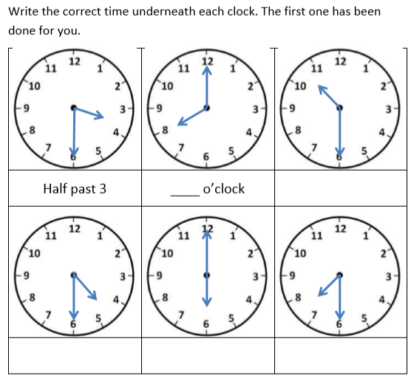

2.
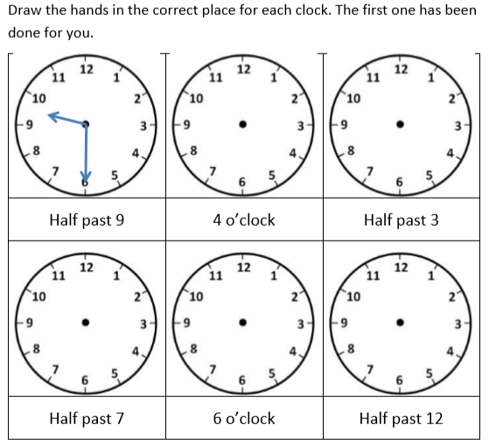

Challenges
1.
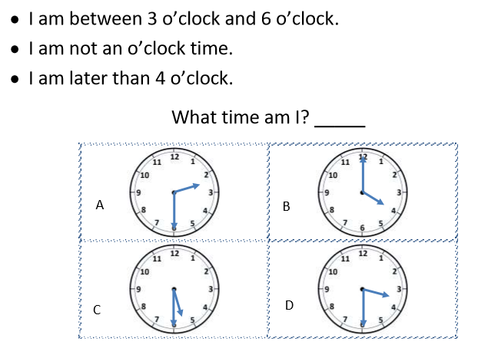

2.
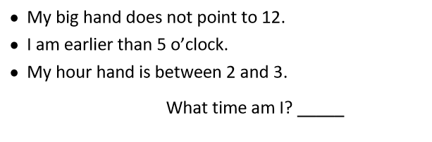

3.
