Monday 30th March 2020
Your topic learning today is to watch the following episode of Planet Earth. It is all about mountains and takes you through the Himalayas – the area that we have been focusing on in our topic lessons. It’s quite a long episode (1 hour) so there are no further learning activities for today. You can either watch it here: https://www.bbc.co.uk/iplayer/episode/b0074sg0/planet-earth-2-mountains or you may be able to download it directly onto your TV if you speak to a parent. Enjoy (particularly the snow leopards!).

Tuesday 31st March 2020
Below is a fictional account of a sighting of a Yeti. The Yeti or Abominable Snowman is a fictional creature who is taller than an average human and is said to inhabit the Himalayan mountains. Using the report and the range of images of the legendary creature, brainstorm ideas about the mysterious Yeti including what type of creature it could be, where it lives, its diet, how it survives in The Himalayas.

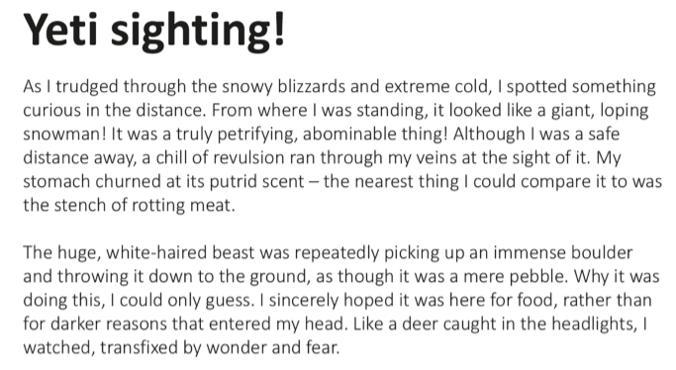
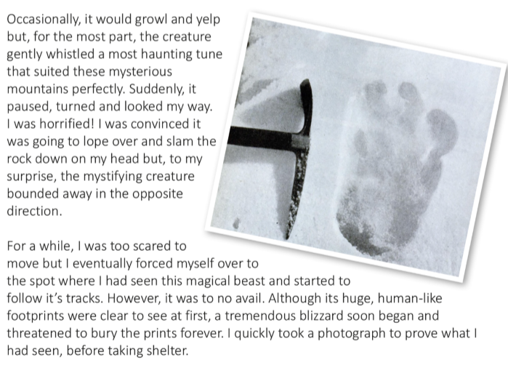
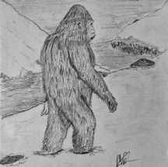
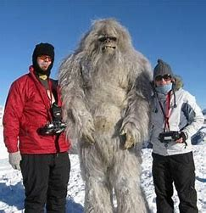
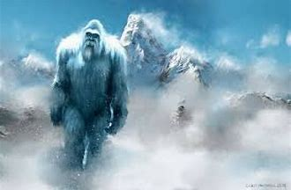
Images of a Yeti

