Maths, Year 2 – 14.5.20
Your maths tasks today is to answer the questions below.
There is not a learning intention today, please just write the date. You do not need to print this page, you can number the answers in your maths books.
Learning is due back today please

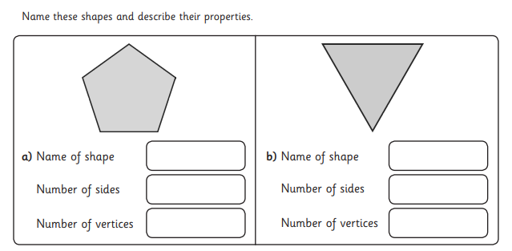

2.
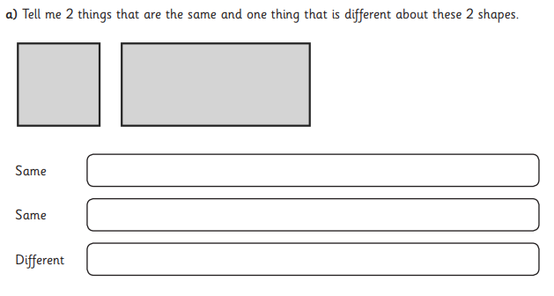

3.
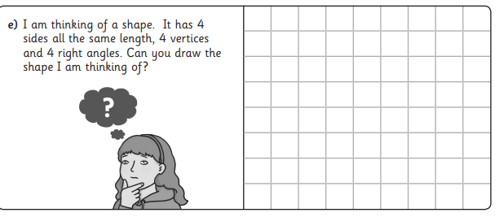

4.
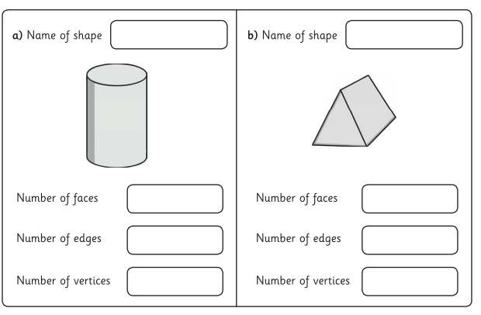

5.
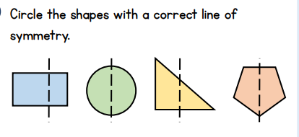
Shape 1 Shape 2 Shape 3 Shape 4

(please write in your maths books shape numbers for answer)

6.
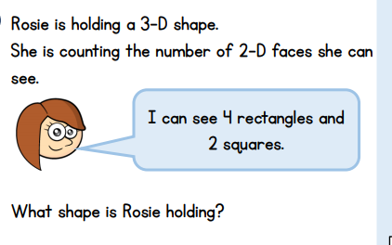

7.
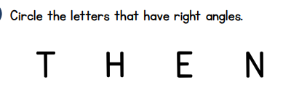
Write the letters in your maths books that have right angles

