Tuesday 2nd June
Today, you are going to do some magic tricks. Just like Abdul Kazam in our book ‘Leon and the Place Between’.
Think of a magic word to use, such as:
- Abracadabra
- Hocus pocus
Please send me photos of you doing your magic tricks
You can choose from the magic tricks below, or you may want to do them all:
Magic trick 1 - Pepper and water magic trick
This is an easy magic trick that doesn’t need much effort. When someone from the audience puts their fingers into the water to separate pepper, nothing happens. When you dip your hands, the pepper separates, and magic happens!
You will need:
- Water
- Soap
- A cup
- Pepper
How to do the trick:
- Before the performance, rub a regular soap on your fingers. This is the secret.
- As you dip your fingers into the cup, the soap will separate the pepper.
There is also a video to help you https://www.youtube.com/watch?v=Nypo6kZVqmw

Magic trick 2 – Rubbery pencil
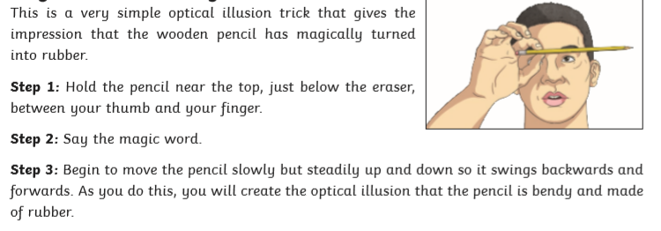

Magic trick 3 – Walking through paper
