Wednesday 22nd April 2020
We are going to continue practising rounding decimals today. This time we are going to round to one decimal point. Begin by watching the short video and then you can put your learning into practise by rounding the decimals below to one decimal point.

Year 5:
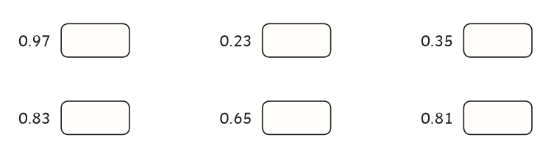
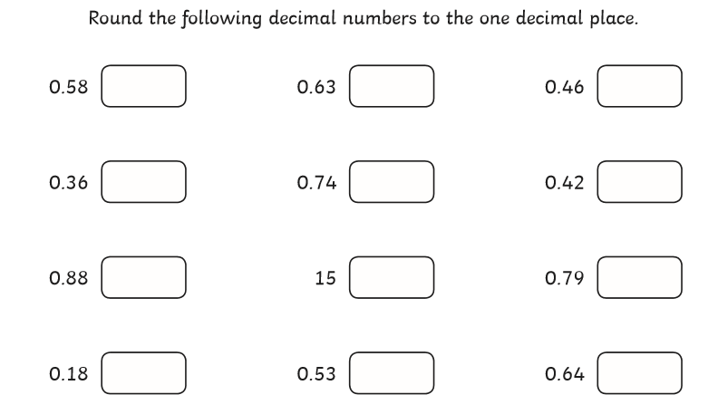

Year 6
