Maths – 18.6.20 (Year 3)
Your maths task today involves using your problem solving skills. There is also an additional challenge.
These clocks have been reflected in a mirror. What times do they say?
Draw the correct time in the clocks underneath (or draw the clocks in your book)
- Think about where the hour hand is pointing, then look at the minute hand.
- The numbers are also back to front, can you figure them out to help you tell the time?
- You can use a mirror to help you and to check your answers.

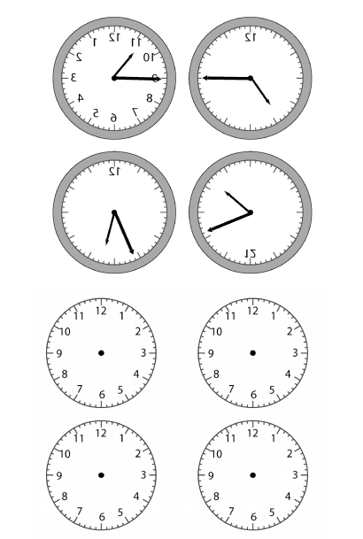
Challenge:
Can you draw your own clock that is reflected?

