Mosi Class Learning Week Beginning 6th July
This week you will all be thinking about the school holidays and are perhaps beginning to think about your new teachers in September. I know that they will be eager to find out as much about you as they can! With that in mind, your learning this week focuses on All About Me. Choose from the tasks below throughout the week. You do not need to complete each task but try and choose a range of activities. Remember to email me a picture of your work each day so that I can continue to give you lots of team points. Have fun! Mrs Russell
Curriculum Area | Task
English | Create an information booklet about an area/topic that interests you. This is your opportunity to be in charge of your own learning and share some of your interests with me.
English | Create a booklet about your family. Include details such as who they are, their interests and hobbies and what you enjoy doing with them. Include some photographs in your booklet.
English | Guess Who? Write a description of someone in your class for someone else to guess who.
English | Write a biography poem (see example on school website)
Reading | What are your favourite books? Write some recommendations of books that other people should read.
Art | Draw a picture of your family and label it with who’s who.
Art | Use your handprints or footprints to create a picture of yourself.
Art | Draw a self-portrait of yourself, you’ll need a mirror to do this. You can draw your portrait in one of the frames attached on the school website.
Design & Technology | Make your own photo frame and then draw a picture of your family in it.
Music | Watch the video clip of My Favourite Things from The Sound of Music. www.youtube.com/watch?v=DGABqdbtQnA What are your favourite things? Write your own verse to the song or a paragraph to explain some of your favourite things.
English | What if you could only choose one favourite thing? What would it be and why? Write your own piece describing your favourite thing in detail and explaining why it means so much to you. You can draw it at the end. Here is an example.  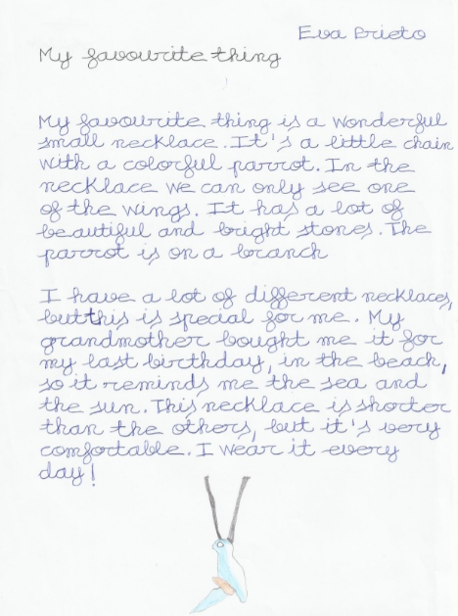
PSHE | Create an A-Z list of things about you e.g. A = Amazing, B = Baker, C = Chatty etc. This could also be used to make an A-Z list of your favourite things or people.
Topic | If you were an animal, what animal would you be? Consider these characteristics and compare them to an animal to create a presentation justifying why you think you are like that animal.
Art | Using magazine, newspapers or internet pictures create a “me” board – select pictures of things you like, people you admire, colours, items you would like (the Argos catalogue works well for this task).
Art | Using resources that you can find in the garden (leaves, sticks, daisies, grass etc) create a piece of art that represents you.
PSHE | What do you find tricky? What would you like to be better at? Work on it at home to become more confident.
Topic | Create your own lockdown time capsule. Include some writing about yourself and your interests and some photographs.  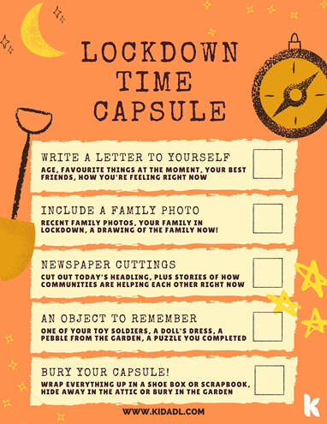
Art | Make a paper plate face of yourself.

