Maths – Wednesday 22nd April
LI: To identify 2D shapes on the surface of 3D shapes
Your learning today can be completed in your squared paper home learning book. Please write the date 22.4.20 and the learning intention:
- You can either print (in black and white is fine) and fill in table or draw the shape from the table and write the sentences. You can use the 3D mat to help you from today’s resources on Torak’s home learning page.
- You also have a challenge.
Please scroll down …

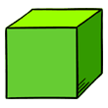 | Name of 3D shape  2D shape I can see
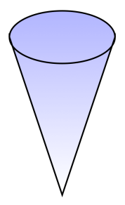 | Name of 3D shape  2D shape I can see
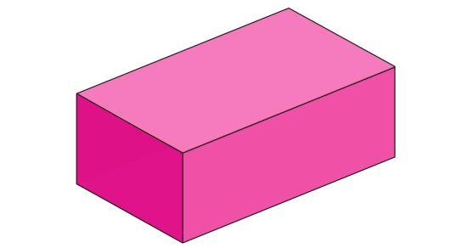 | Name of 3D shape  2D shape I can see
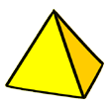 | Name of 3D shape  2D shapes I can see
Name of 3D shape

2D shape I can see
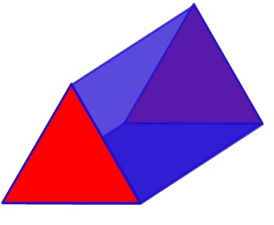 | Name of 3D shape  2D shapes I can see

*Challenge – all year 3’s and I would like year 2’s to have a go please. (You do not need to print out. Please write the word ‘challenge’ in your maths book and then your answer)

