Learning for 31st March 2020

Your learning today is numbered 1 – 3.

Tasks 1 and 2 are due back Wednesday 1st April please. Task 3 is due back Thursday 2nd April.

31.3.20
LI: To recognise perpendicular lines
Success criteria | My teacher thinks I can | I think I can
I can identify perpendicular lines
I can draw perpendicular lines
I can create a ‘Piet Mondrian’ style drawing using parallel and perpendicular lines

Remember perpendicular lines meet at right angles

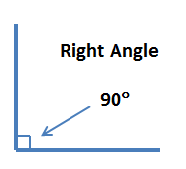

- Can you circle the pairs of perpendicular lines?

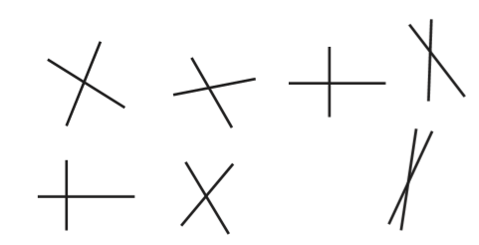
- Can you circle the lines which are parallel using a red pencil and perpendicular using a blue pencil?

parallel perpendicular

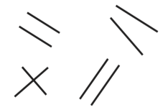

- For your third task, I would like you to design your own ‘Piet Mondrian’ style drawing using parallel and perpendicular lines.

*Remember to use your ruler to draw all the lines and you can use your coloured pencils from your pack to colour. Look at the colours Piet uses. He uses yellow, blue, black and red. Your drawings will also need to use these colours please

*This task does not need to be completed until Thursday as I would really like you to take your time. I would like to create a new maths display in our classroom of all your wonderful ‘Piet Mondarian’ style drawings. You can use your maths book for this task or plain paper.

I have included some examples of Piet Mondrian’s artwork to help you. You can also use some examples from the link to the Tate modern website that is on today’s powerpoint.

