Tuesday April 20th
Maths
Mental Maths Warm up-
Use a ball or beanbag. Throw your ball to each other and count each catch. To make it harder, take a step back, to make it easier, roll the ball along the floor. Can you count in twos? [ Count your catch and whisper your partners.] How far can you count?

Maths Main Focus – Pattern hunt
Learning Objective- To explore pattern in a range of contexts including shapes, colours, sizes, actions and sounds.
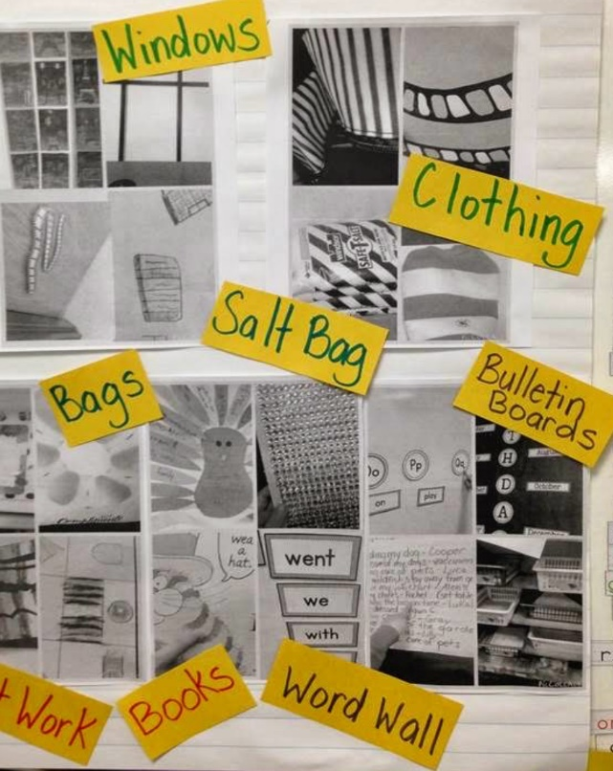
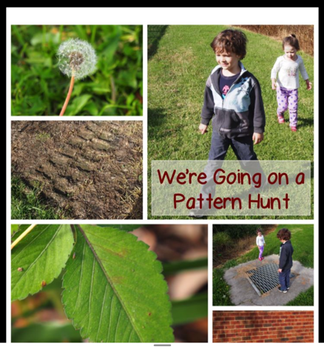

Patterns are everywhere!
Look around you and hunt for patterns. Look at the walls, carpets, curtains and fabrics. Look in the kitchen, bathroom and go outside. Record your findings by taking pictures or drawing some pictures and get someone to help you label them. Make a montage of your pictures. See above.
Can we hear patterns – music, beats and story patterns.

