Maths – 16.6.20
LI: To tell the time using ‘quarter past’
There are 3 questions and challenges to complete today.
You do not need to print, please just write your answers numbering 1, 2, 3.
Show the same time on your clocks as you answer each question.
1.
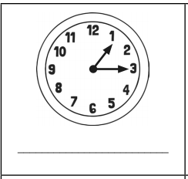

2.
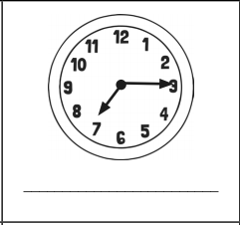

3.
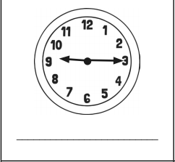

Challenges
Please answer at least one of the challenge questions –1 star, 2 stars or 3 stars (mild, spicy, hot)

Sophie and Hannah are sisters. Sophie says that there are 4 quarters in one hour, but Hannah says that there are 2 quarters in an hour.
Who is correct? Explain your answer.

2.
Ruby’s mum said that she can go out to play for three quarters of an hour. How many minutes can Ruby go out to play?

3.
