Wednesday 29th April 2020
LI: To identify & express the feelings of a character

Good morning Mosi Class,

We are going to continue planning our diary entries today before we start writing them up tomorrow. Yesterday you began to plan the facts of your diary but today we want to add in some feelings and emotions so that when you write your diary it is personal.

In order to help you think about what you might be feeling or thinking in your Anne Frank-style diary entry, begin by reading the slides on life in wartime Amsterdam. This will give you an idea of what life might have been like for Anne Frank and for you in your diary entry. These events might evoke some emotions. You might even want to refer to one of these key moments in your diary entry.

Once you have read the slides, think about how the events made you feel. You will need to make sure that when you write your diary, you include some personal thoughts and feelings so that your diary comes alive. Look at these examples from Anne Frank’s diary that include personal feelings…

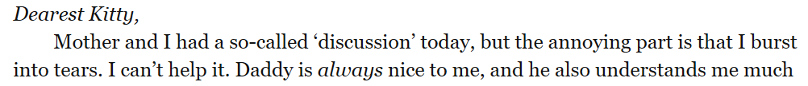

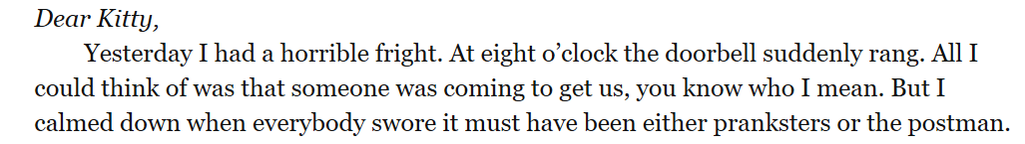
Today, your task is to think about the feelings that you might include in your diary entry. To help you choose the correct vocabulary, use the ‘adjectives for feelings’ resource.

Think of a few emotions that you might be feeling in your diary entry and choose the correct vocabulary from the adjectives list. Explain how you are feeling while hiding and why you might be feeling that way. You do not need to write lots as we are simply putting together thoughts and ideas at the moment ready for writing our diary entry tomorrow.

