Tuesday 2nd June 2020
Foundation Stage Maths instructions
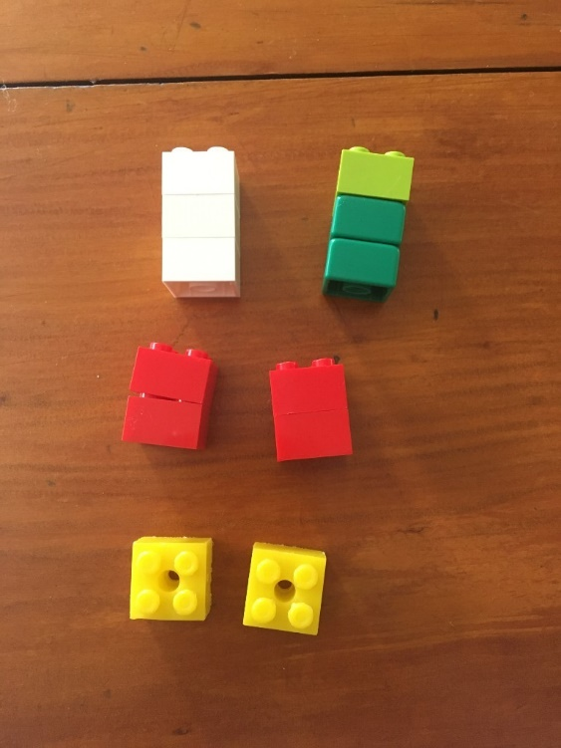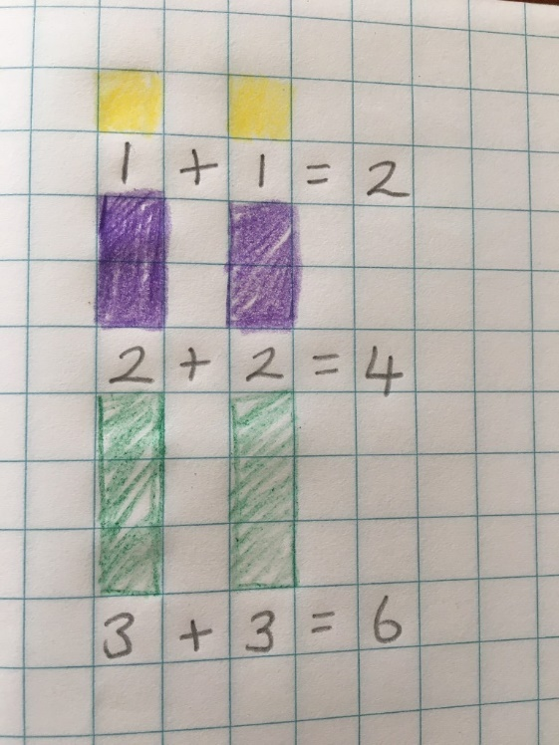

Use blocks to make double towers to 5 or 10. Count carefully using the language 'Double 1 is...'
Record your findings by drawing and colouring in towers on grid paper and write a number sentence underneath.

