Maths – 22.6.20
LI: To convert to digital time
There are 3 questions to complete and the option of mild, spicy and hot challenges, or you may wish to answer all 3 challenges.
1.
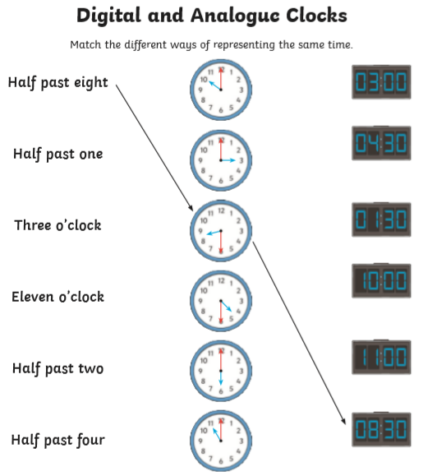
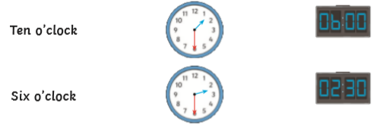

2.
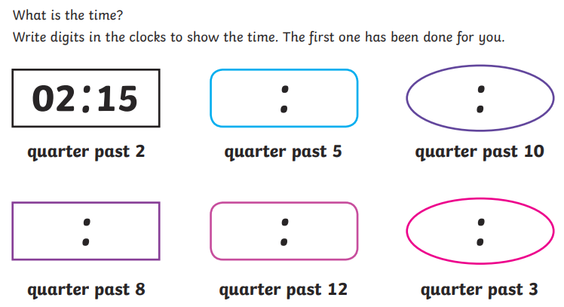

3.
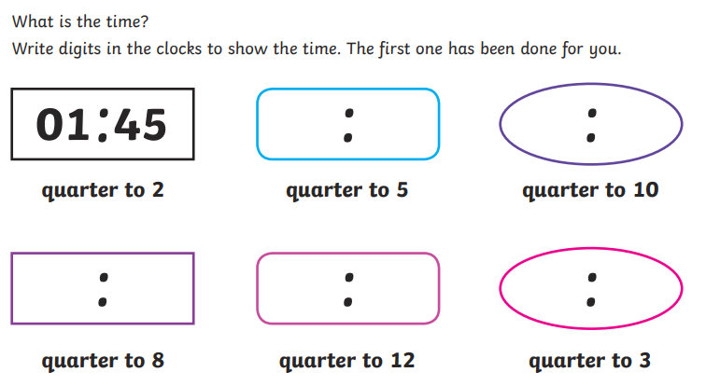

Challenges

