Hello Year 4, I hope you are excited to see your maths learning this week. This is a great opportunity for you to work at your own pace and develop some fantastic maths skills. As ever, do your best, present your work carefully and remember to email me your work each day. I’m looking forward to seeing how you get on.
To help you with your maths this week, you should use the ‘properties of shape’ knowledge organiser in your resources pack. It will help you to remember everything you need to know about the properties of shapes for your lessons this week.

Monday 23rd March
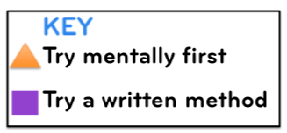
- Begin your maths lesson today by trying to complete these 5 questions in 5 minutes in your maths book. Good luck!

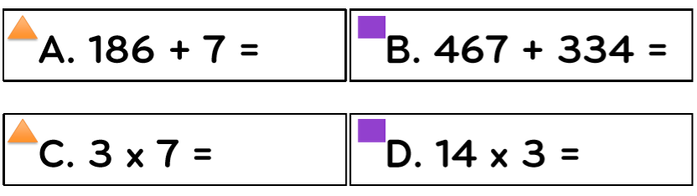

- Go through the presentation ‘Triangles’.
- Using the information in the PowerPoint and your knowledge organiser to help you, draw a triangle that matches the label into each of these boxes below and write some facts about each triangle. You could draw the same grid into your book.
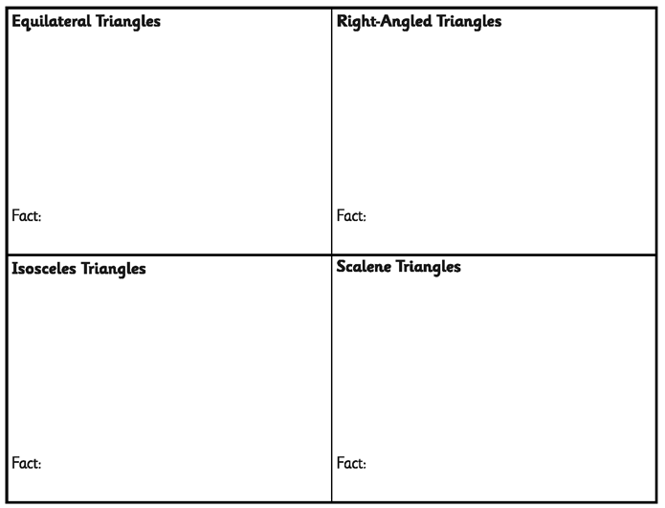
Tuesday 24th March
Begin today’s maths lesson by answering these rapid reasoning questions in your book.
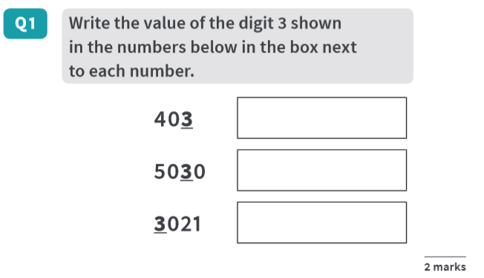
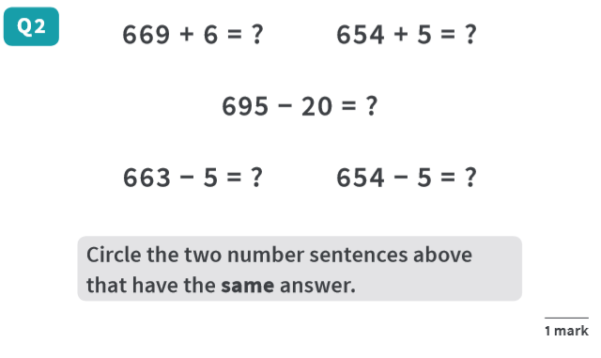

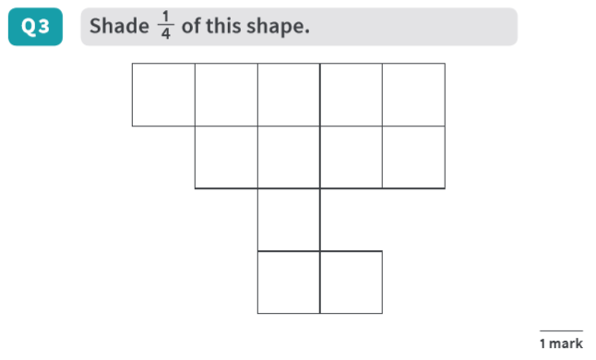

Using your knowledge organiser as a prompt, go onto the MyMaths website and log in. You will find a task there ready for you to complete today. The questions are all about properties of triangles. Some are quite tricky, but I know you can do it! You will find your log on details in your resource pack (inside the plastic wallet). If you have any difficulties getting on to the website, then please email me and I will help you.

Wednesday 25th March

Here are some quick-fire arithmetic questions for you to practice as a warm up for today’s lesson. Time yourself and let me know how long it takes for you to complete these few questions.

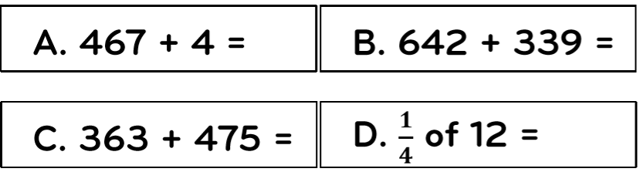

Look at the PowerPoint quadrilaterals. It will tell you everything that you need to know about these shapes. Go through it carefully and make sure you understand what you are reading. When you have finished it, draw the different quadrilaterals into the correct boxes (see below) and write a mathematical fact about each shape.

Thursday 26th March
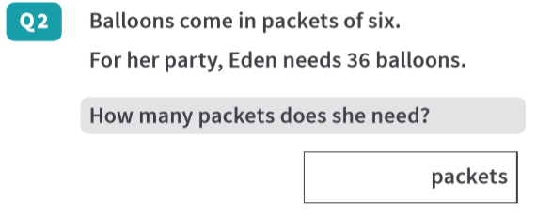
Begin today’s lesson with these rapid reasoning questions to consolidate your learning so far this year.

Below are some different shapes. Can you sort them into the Venn diagrams below? Draw one of the Venn diagrams into your book (remember to label it) and sort the shapes. You could draw the shapes into your Venn diagram or simply write the name of it. When you have finished, draw the next Venn diagram and sort them again.
Extra Challenge (for extra team points!)

Draw a different Venn diagram and sort the shapes into the categories that you have chosen.

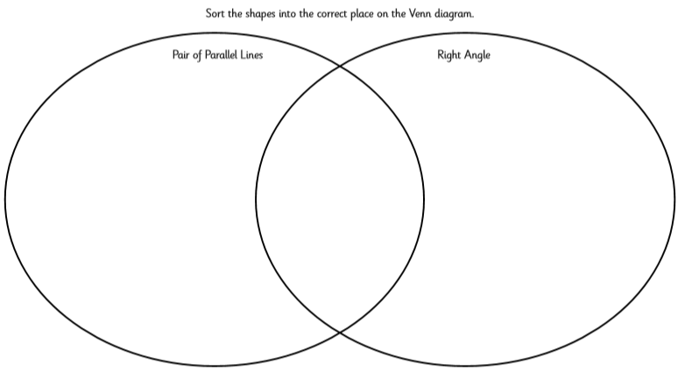

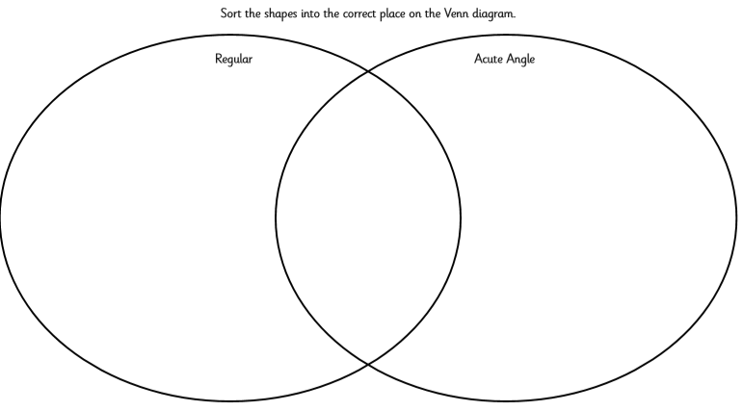

Friday 27th March

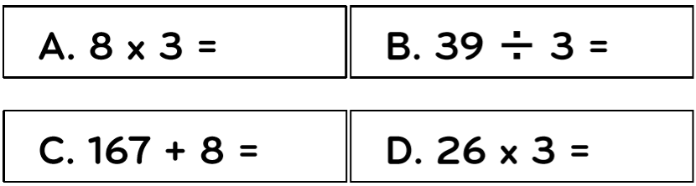
Here are some quick-fire arithmetic questions to get you ready for maths today.

Your maths learning today is taking you back to thinking about triangles. We are going to learn about angles today. Your top tip for today, is to remember that an acute angle is an angle that is less than 90º and an obtuse angle is larger than 90º. You have looked at acute and obtuse angles before (in Year 3) but if you need a reminder then this short video is very helpful. https://www.youtube.com/watch?v=4y6HRjxVAeI
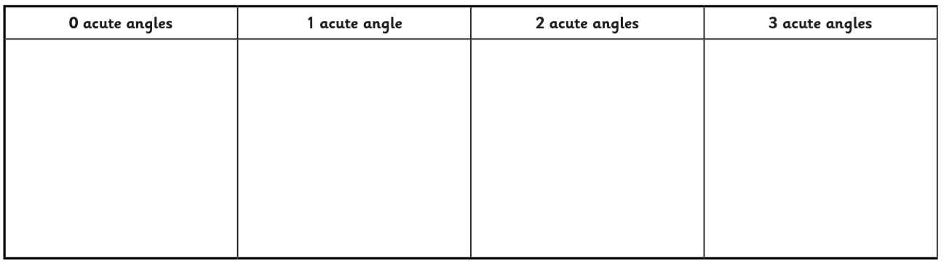
Go through the PowerPoint Acute or Obtuse Angles, then sort the quadrilaterals into groups based on their angles. You could draw the quadrilaterals into a chart in your book.
