The library is so boring!

Of course, I’ll be good!

We are here. Please be good and don’t cause any trouble!

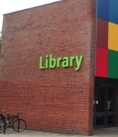

Come on Scaly, we must go to the library. I need to finish my homework.





M

Maybe!





I’m hungry! There must be some smelly cheese around here. Maybe at the top of this bookshelf.



I am going to look for a book. Will you stay unnoticed please?



Yes, I will be as quiet as a mouse.

To be continued …





HELP! The books have fallen!

**BANG! CRASH!**







What have you done Scaly?

I’m sorry George. I was just looking for some smelly cheese!





