Tuesday 21st April – Learning due back by Thursday 23rd April
1.Your learning for today is to sort the seeds shown below by how they are dispersed.
2.You do not have to print out the pictures of the seeds, you can copy and draw the pictures from your computer screen.
3.I would like you to think about the following questions:
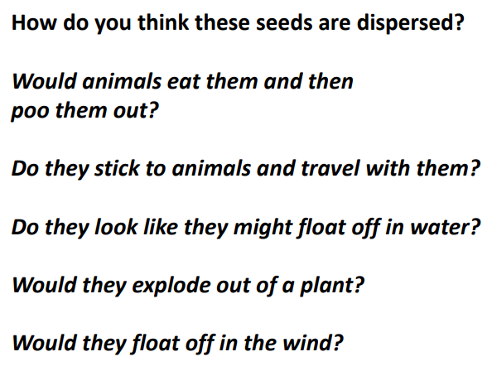
4.In your blank home learning book, I would like you to write headings for each of the dfferent ways seeds are dispersed. For example:
Seeds that are dispersed by wind
Seeds that explode out of a plant
Seeds that float on water
Seeds that are disperesed by animals
Then underneath each heading, I would like you to draw a picture of the seed and label it.
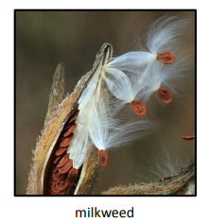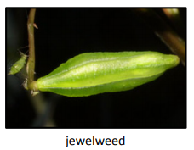
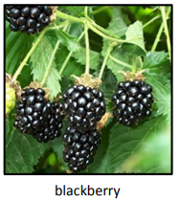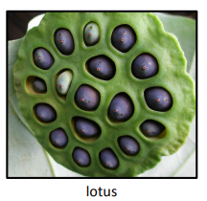
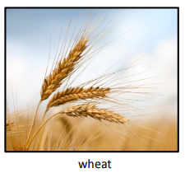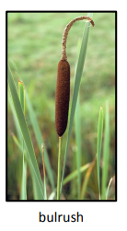

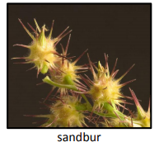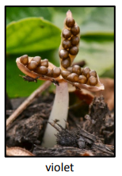

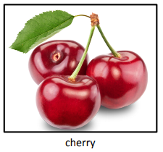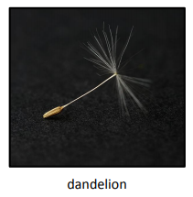

*CHALLENGE
Can you research some more seeds and add them to your learning?

