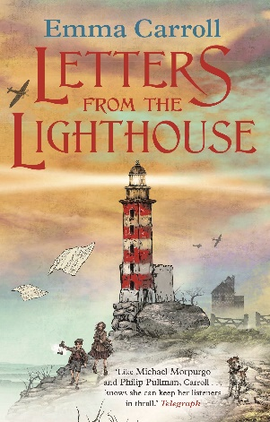
Chapter 2 – Make Do And Mend
Year 4 comprehension questions

Choose three of the questions to answer. Find and talk through the answers to each of your questions with an adult first. Decide what you are going to write and say each sentence together before you write. Then write down your answers.
Answer all of the questions. Find and talk through the answers to each of your questions with an adult first. Decide what you are going to write and say each sentence together before you write. Then write down your answers.
Answer all of the questions independently.
Questions
(Please note that the answers to each can be found on the pages of the PowerPoint slides marked in red)
What does it mean to have a “few minor cuts”? Slide 5
How did Olive get to the hospital? Slide 4
What was the nurse called? Slide 6
What did the nurse make? Slides 6 and 8
Who was forced to wear yellow stars, banned from shops and schools and parts of towns? Slide 16

