Tala Class Topic Medium Term Plan – Autumn 2

We are technologists

 | Week 1 | Week 2
 | Session 1  Who invented computers?  KS1 - HISTORY  To know where the people and events studied fit within a chronological framework  Hi1/1.1 changes within living memory. Where appropriate, these should be used to reveal aspects of change in national life  Hi1/1.2 events beyond living memory that are significant nationally or globally  Hi1/1.3 the lives of significant individuals in the past who have contributed to national and international achievements. Some should be used to compare aspects of life in different periods  KS1 - COMPUTING  Co2/1.5 recognise common uses of information technology beyond school  EYFS  Understanding the World  Technology (40-60+)  Completes a simple program on a computer.  Uses ICT hardware to interact with age-appropriate computer software.  (ELG) – Children recognise that a range of technology is used in places such as homes and schools. They select and use technology for particular purposes.  Teaching input  1.Discuss with chn that we are going to be looking at technology this term – what does technology mean? What technology do we use? Refer back to our book ‘Dot.’ and ‘Hello, Hello’. (Technology is putting knowledge to practical use to solve or invent useful tools)  2.Chn partner share – When chn class share reiterate that the technology they use (e.g, ipad, mobile phone) is invented by a person who designed the machine. Focus on my laptop and discuss that laptops and computers didn’t always look like this …  3. Talk about history of computing using PP (Ada Lovelace, Alan Turing, 1980’s technology). A computer is a type of machine. It doesn’t have a brain like us and it can’t think or have ideas, but it can follow stored instructions and do lots of useful things.  4.Watch video about changes in technology over the years.  https://www.bbc.co.uk/bitesize/topics/zbhgjxs/articles/ztrq7ty  5.Open discussion with chn based on their observations and questions.  4. Watch video about chn trying to use technology from 1980’s  https://www.bbc.co.uk/newsround/35716623  5.Explain that we are going to place photos of technology in a timeline starting from 1815 – over 200 years ago to technology we use today.  6.Chn to work in small groups placing technology in a timeline.  Session 2  Exploring technology  Teaching input  1.Have an ipad and ask chn how to turn it on. How do I turn up the sound?  2.Using laptop ask chn how it is turned on, do I touch the screen like an ipad?  3. Discuss the key features of technology we use in school and discuss their purpose  4.Chn to label parts of technology in small groups/pairs – e.g  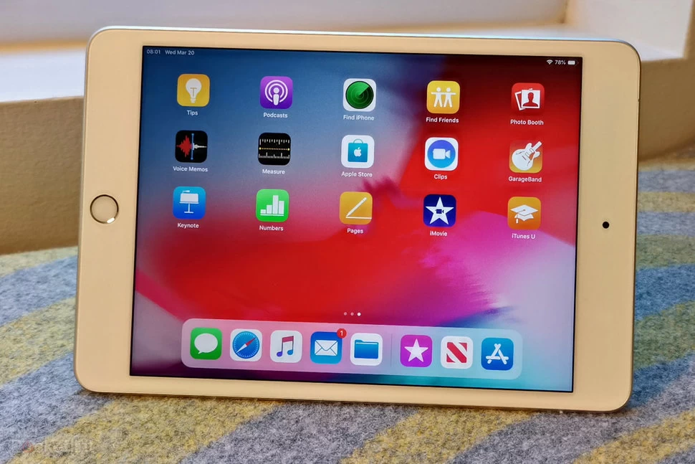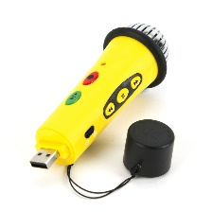  5. ‘How do you think we turn them on?’ ‘What are the buttons for?’ ‘How do you turn change the volume?’  6.Chn to explore how to use technology in groups and label the parts | Session 3  Create a computer  Exploring and using media and materials (40-60+)  Explores what happens when they mix colours.  Experiments to create different textures.  Understands that different media can be combined to create new effects.  Manipulates materials to achieve a planned effect.  Constructs with a purpose in mind, using a variety of resources.  Uses simple tools and techniques competently and appropriately.  Selects appropriate resources and adapts work where necessary.  Selects tools and techniques needed to shape assemble and join material they are using.  ELG) – Children use what they have learnt about media and materials in original ways, thinking about uses and purposes. They represent their own ideas, thoughts and feelings through design and technology, art, music, dance, role play and stories.  DT1/1.1 Design  DT1/1.1a design purposeful, functional, appealing products for themselves and other users based on design criteria  DT1/1.1b generate, develop, model and communicate their ideas through talking, drawing, templates, mock-ups and, where appropriate, information and communication technology  DT1/1.2 Make  DT1/1.2a select from and use a range of tools and equipment to perform practical tasks  DT1/1.2b select from and use a wide range of materials and components, including construction materials, textiles and ingredients, according to their characteristics  DT1/1.3 Evaluate  DT1/1.3a explore and evaluate a range of existing products  DT1/1.3b evaluate their ideas and products against design criteria  DT1/1.4 Technical Knowledge  DT1/1.4a build structures, exploring how they can be made stronger, stiffer and more stable  DT1/1.4b explore and use mechanisms, in their products.  Teaching input  1.Recap on previous lesson – can chn remember Ada Lovelace and Bill Turing – refer to the chns display to support.  2.Discuss that in school we use an ipad a lot to play phonics games, watch videos and Mrs Cannings uses it a lot to surf the internet (just like Dot from our book) and take photos of the chn doing fantastic learning.  3.Who invented the ipad?  - Small tablet computer made by Apple.  - The first ipad was made in 2010 by Steve Jobs  4.Chn to discuss where to place Steve jobs and the first ipad on class timeline  5.Explain that the children are going to be ‘technologists’ and invent their own computer. ‘What will it do?’ Partner talk and class share.  6.Show chn computer that I made and what it does.  7.Chn to then create their own using a large range of resources.  Session 4  Chn to share their computer creation with the class and record on ipad for chn to watch back  1.Discuss with chn that we are going to share our computer creations with the class. Ask how can we do this using technology? Partner share and scaffold as required  2.After discussion we would have decided on using an ipad to record ourselves. How do we record? How do we watch our recording?  3.Show chn whilst they repeat the process in groups.  4.Chn to then record one another in their groups and play back the video.  5.Class share.

 | Week 3 | Week 4
 | Session 5  Keeping safe online  Co2/1.6 use technology safely and respectfully, keeping personal information private; identify where to go for help and support when they have concerns about material on the internet or other online technologies  DT1/1.1 Design  DT1/1.1a design purposeful, functional, appealing products for themselves and other users based on design criteria  DT1/1.1b generate, develop, model and communicate their ideas through talking, drawing, templates, mock-ups and, where appropriate, information and communication technology  Teaching input  1.Who invented the internet and the World Wide Web?  2 Show pp about Sir Tim Beners-Lee, discussing how the internet has changed the way we communicate. Watch video  https://www.bbc.co.uk/bitesize/topics/zymykqt/articles/zgwnsbk  3.Discuss with chn if they have used the internet to send an email, receive an email – show example  3.Ask chn where on our timeline we need to add Sir Tim Berners-Lee  4.Chn share about all the great things we use the internet for. Discuss that we can’t see the person on the other side, so we must be very careful about the information we share.  5. Watch video about Internet safety and discuss  https://www.bbc.co.uk/bitesize/topics/zfcvhbk/articles/zkcj92p  6.Watch Jessie and Friends and chn discuss in groups what they would do if it happened to them – then class share with other groups. Write chns ideas on board.  7.Chn to use ideas on board to plan their poster about keeping safe online.  Session 6  Make a poster about keeping safe online  DT1/1.2 Make  DT1/1.2a select from and use a range of tools and equipment to perform practical tasks  DT1/1.2b select from and use a wide range of materials and components, including construction materials, textiles and ingredients, according to their characteristics  DT1/1.3 Evaluate  DT1/1.3a explore and evaluate a range of existing products  DT1/1.3b evaluate their ideas and products against design criteria  Teaching input  1.Recap on previous lesson  2.Model how to use ideas from the ‘planning’ for our poster to create and make it.  3.Chn to discuss what materials they can use for their desired effect – partner share then class share  4.Chn then evaluate their poster against their original plan/criteria – share with peers in group and class share. | Session 7  How do computers work?  Algorithms  Teaching input  1.Ask chn ‘how do computers work?’ ‘How do they know what to do? Partner share then class share.  2.Explain that computers need to be given special instructions to know what to do. This is called an algorithm. Watch video  https://www.bbc.co.uk/bitesize/topics/z3tbwmn/articles/z3whpv4  3.Explain that an algorithm is a list of rules to follow in order to solve a problem. Algorithms need to have their steps in the right order. Think about an algorithm for getting dressed in the morning. What if you put on your coat before your jumper? Your jumper would be on top of your coat and that would be silly! When you write an algorithm the order of the instructions is very important.  4.Chn to explain to their partner how to clean their teeth – an algorithm  5. https://www.barefootcomputing.org/resources/dance-move-algorithms  Explain to chn that they are going to be dance instructors. Show chn the different dance move cards that they can use and ask them to repeat as you model the moves (e.g. jump, spin, wave arms). Hold up each card in turn and ask chn to show you the different moves to ensure all are familiar with all the moves before starting.  6.Explain to the class that they are going to create their own dance routine by choosing a sequence of moves. Reiterate that a sequence of instructions to get something done is called an algorithm.  7.Place a sequence of 5 or 6 move cards on the board and ask the pupils to follow the instructions to complete the dance routine. Ask what happens if you swap two cards around? Explain that changing the order of the cards will change the routine.  8. Chn to work in small groups to create their own dance routine using the cards.  9.Chn share their routines with the class – their algorithms.  10. Ask chn ‘why the order of their instructions are so important, what would happen if I swapped the cards around, would your dance routine stay the same?  Additional algorithm  Create a crazy character – algorithm  https://www.barefootcomputing.org/resources/crazy-character-algorithms  Session 8  Using a beebot to create an algorithm  Co2/1.1 understand what algorithms are; how they are implemented as programs on digital devices; and that programs execute by following precise and unambiguous instructions  Co2/1.2 create and debug simple programs  Co2/1.3 use logical reasoning to predict the behaviour of simple programs  Co2/1.4 use technology purposefully to create, organise, store, manipulate and retrieve digital content  Co2/1.5 recognise common uses of information technology beyond school  Co2/1.6 use technology safely and respectfully, keeping personal information private; identify where to go for help and support when they have concerns about material on the internet or other online technologies  EYFS  Understanding the World  Technology (40-60+)  Completes a simple program on a computer.  Uses ICT hardware to interact with age-appropriate computer software.  Teaching input  1.Recap on previous lesson – ‘what is an algorithm?’  2.Explain that now we know that an algorithm is a sequence of instructions, we are going to programme a beebot to follow instructions.  3.First, we need to know which way is left and right. Show chn ‘L’ shape for left hand helps us to remember our left and right. Assess chns understanding and provide L and R signs for chn as required.  3.Model to class how to use a beebot using beebot instruction cards  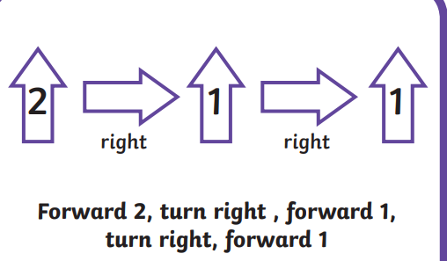  – chn to follow along in small groups, taking turns.  4.How do we ‘debug’ of we make a mistake? Show chn how to debug on a beebot – chn to repeat in group  5.Provide chn with differentiated instruction cards to work in groups

 | Week 5 | Week 6
 | Session 9  Using a beebot to create an algorithm  Teaching input  1.Recap on previous lesson  2.Have the map used for beebots and ask chn how I move from one object to the other.  3.Chn to discuss in groups then use ‘instruction cards’ to place in order.  4.Chn to then take turns to input instructions into beebot to test their sequence of instructions.  5.Using beebot mats, chn to create their own algorithms  Session 10  Creating algorithms on Scratch  Co2/1.1 understand what algorithms are; how they are implemented as programs on digital devices; and that programs execute by following precise and unambiguous instructions  Co2/1.2 create and debug simple programs  Co2/1.3 use logical reasoning to predict the behaviour of simple programs  Co2/1.4 use technology purposefully to create, organise, store, manipulate and retrieve digital content  Co2/1.5 recognise common uses of information technology beyond school  Co2/1.6 use technology safely and respectfully, keeping personal information private; identify where to go for help and support when they have concerns about material on the internet or other online technologies  Teaching input  1.Model how to use ‘scratch jnr’ with a half class input – chn to follow along using ipads.  2.Repeat with other half of class.  2.Support where required.  Assess understanding of FS chn to use scratch – They also have continuous provision to support ‘understanding the world’ (please see reception medium term plan) | Session 11  Using algorithms on Scratch Jnr  Co2/1.1 understand what algorithms are; how they are implemented as programs on digital devices; and that programs execute by following precise and unambiguous instructions  Co2/1.2 create and debug simple programs  Co2/1.3 use logical reasoning to predict the behaviour of simple programs  Co2/1.4 use technology purposefully to create, organise, store, manipulate and retrieve digital content  Co2/1.5 recognise common uses of information technology beyond school  Co2/1.6 use technology safely and respectfully, keeping personal information private; identify where to go for help and support when they have concerns about material on the internet or other online technologies  EYFS  Understanding the World  Technology (40-60+)  Completes a simple program on a computer.  Uses ICT hardware to interact with age-appropriate computer software.  (ELG) – Children recognise that a range of technology is used in places such as homes and schools. They select and use technology for particular purposes.  Repeat of session 10

EYFS

Expressive Arts and Design
Objectives:
Exploring and using media and materials (40-60+)
Explores what happens when they mix colours.
Experiments to create different textures.
Understands that different media can be combined to create new effects.
Manipulates materials to achieve a planned effect.
Constructs with a purpose in mind, using a variety of resources.
Uses simple tools and techniques competently and appropriately.
Selects appropriate resources and adapts work where necessary.
Selects tools and techniques needed to shape assemble and join material they are using.

(ELG) - Children sing songs, make music and dance, and experiment with ways of changing them. They safely use and explore a variety of materials, tools and techniques, experimenting with colour, design, form and function.

Understanding the World
Objectives:
Technology (40-60+)
Completes a simple program on a computer.
Uses ICT hardware to interact with age-appropriate computer software.

(ELG) – Children recognise that a range of technology is used in places such as homes and schools. They select and use technology for particular purposes.

KS1 - COMPUTING
Pupils should be taught to:
Co2/1.1 understand what algorithms are; how they are implemented as programs on digital devices; and that programs execute by following precise and unambiguous instructions
Co2/1.2 create and debug simple programs
Co2/1.3 use logical reasoning to predict the behaviour of simple programs
Co2/1.4 use technology purposefully to create, organise, store, manipulate and retrieve digital content
Co2/1.5 recognise common uses of information technology beyond school
Co2/1.6 use technology safely and respectfully, keeping personal information private; identify where to go for help and support when they have concerns about material on the internet or other online technologies

HISTORY – KS1
Hi1/1.1 changes within living memory. Where appropriate, these should be used to reveal aspects of change in national life
Hi1/1.2 events beyond living memory that are significant nationally or globally
e.g. the Great Fire of London, the first aeroplane flight or events commemorated through festivals or anniversaries
Hi1/1.3 the lives of significant individuals in the past who have contributed to national and international achievements. Some should be used to compare aspects of life in different periods
e.g. Elizabeth I and Queen Victoria, Christopher Columbus and Neil Armstrong, William Caxton and Tim Berners-Lee, Pieter Bruegel the Elder and LS Lowry, Rosa Parks and Emily Davison, Mary Seacole and/or Florence Nightingale and Edith Cavell and Edith Cavell

D&T – KS1

DT1/1.1 Design
DT1/1.1a design purposeful, functional, appealing products for themselves and other users based on design criteria
DT1/1.1b generate, develop, model and communicate their ideas through talking, drawing, templates, mock-ups and, where appropriate, information and communication technology

DT1/1.2 Make
DT1/1.2a select from and use a range of tools and equipment to perform practical tasks
DT1/1.2b select from and use a wide range of materials and components, including construction materials, textiles and ingredients, according to their characteristics

DT1/1.3 Evaluate
DT1/1.3a explore and evaluate a range of existing products
DT1/1.3b evaluate their ideas and products against design criteria

DT1/1.4 Technical Knowledge
DT1/1.4a build structures, exploring how they can be made stronger, stiffer and more stable
DT1/1.4b explore and use mechanisms, in their products.

