Science – 12th May 2020
We are going to have a fun and creative lesson today based on conservation.
There are some resources with instructions available to download from todays resources. They include:
- To make an orangutan

- Make an apple bird feeder
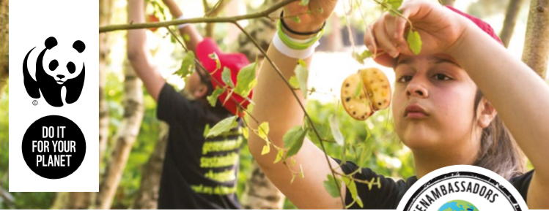

- Make a polar bear lantern
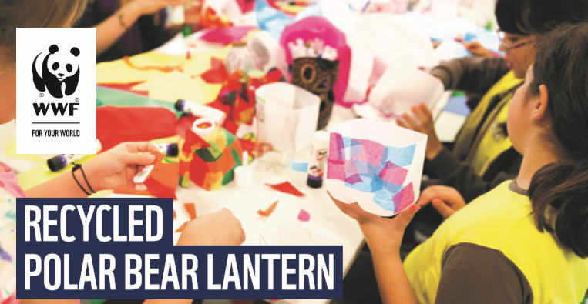
- Or you can come up with your own idea. There are other ideas from https://www.wwf.org.uk/get-involved/schools/activities

