Maths – 24.6.20
LI: To tell the time in 5-minute intervals
There are 2 questions to answer today and you can choose either a mild, spicy or hot challenge. (You do not need to answer them all).
1.
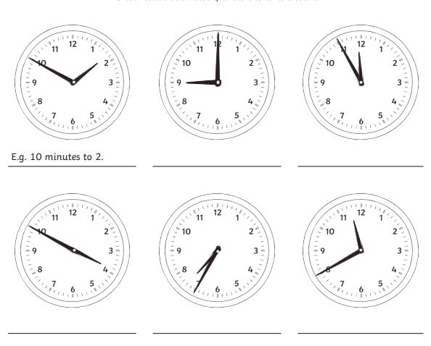
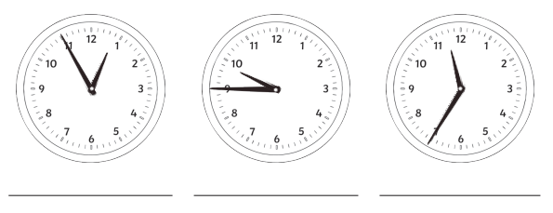
2. Please write the digital time
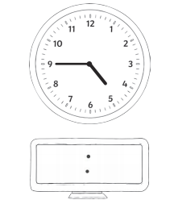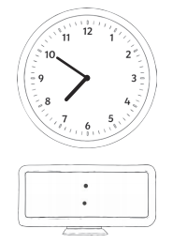
Challenges

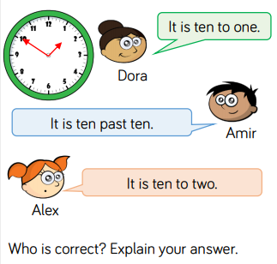

(Hint: use your 5 times table to help you)
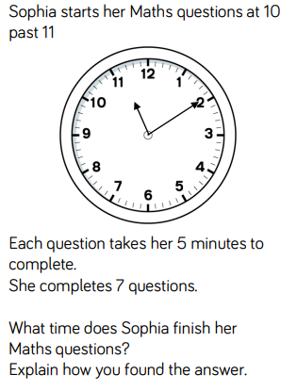

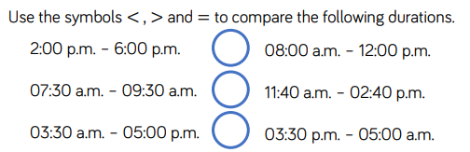

*Remember that < is less than and > is more than
We learnt in class that we can remember this by making the < sign with our left hand.
L(eft) = Less than

