had | Pete  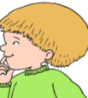 | spade  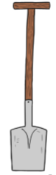 | big | a | .
flowerpot  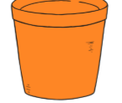 | fat | Mary  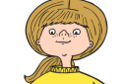 | had | a | .
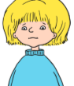  Titch | seed | tiny | the | had | .

